DB2 HADR server

1, create a file named certificate.pem in your working directory(for example: /tmp/ldaptls) and put following content into the file.

-----BEGIN CERTIFICATE-----  
MIIDjjCCAnagAwIBAgIQAzrx5qcRqaC7KGSxHQn65TANBgkqhkiG9w0BAQsFADBh  
MQswCQYDVQQGEwJVUzEVMBMGA1UEChMMRGlnaUNlcnQgSW5jMRkwFwYDVQQLExB3  
d3cuZGlnaWNlcnQuY29tMSAwHgYDVQQDExdEaWdpQ2VydCBHbG9iYWwgUm9vdCBH  
MjAeFw0xMzA4MDExMjAwMDBaFw0zODAxMTUxMjAwMDBaMGExCzAJBgNVBAYTAlVT  
MRUwEwYDVQQKEwxEaWdpQ2VydCBJbmMxGTAXBgNVBAsTEHd3dy5kaWdpY2VydC5j  
b20xIDAeBgNVBAMTF0RpZ2lDZXJ0IEdsb2JhbCBSb290IEcyMIIBIjANBgkqhkiG  
9w0BAQEFAAOCAQ8AMIIBCgKCAQEAuzfNNNx7a8myaJCtSnX/RrohCgiN9RlUyfuI  
2/Ou8jqJkTx65qsGGmvPrC3oXgkkRLpimn7Wo6h+4FR1IAWsULecYxpsMNzaHxmx  
1x7e/dfgy5SDN67sH0NO3Xss0r0upS/kqbitOtSZpLYl6ZtrAGCSYP9PIUkY92eQ  
q2EGnI/yuum06ZIya7XzV+hdG82MHauVBJVJ8zUtluNJbd134/tJS7SsVQepj5Wz  
tCO7TG1F8PapspUwtP1MVYwnSlcUfIKdzXOS0xZKBgyMUNGPHgm+F6HmIcr9g+UQ  
vIOlCsRnKPZzFBQ9RnbDhxSJITRNrw9FDKZJobq7nMWxM4MphQIDAQABo0IwQDAP  
BgNVHRMBAf8EBTADAQH/MA4GA1UdDwEB/wQEAwIBhjAdBgNVHQ4EFgQUTiJUIBiV  
5uNu5g/6+rkS7QYXjzkwDQYJKoZIhvcNAQELBQADggEBAGBnKJRvDkhj6zHd6mcY  
1Yl9PMWLSn/pvtsrF9+wX3N3KjITOYFnQoQj8kVnNeyIv/iPsGEMNKSuIEyExtv4  
NeF22d+mQrvHRAiGfzZ0JFrabA0UWTW98kndth/Jsw1HKj2ZL7tcu7XUIOGZX1NG  
Fdtom/DzMNU+MeKNhJ7jitralj41E6Vf8PlwUHBHQRFXGU7Aj64GxJUTFy8bJZ91  
8rGOmaFvE7FBcf6IKshPECBV1/MUReXgRPTqh5Uykw7+U0b6LJ3/iyK5S9kJRaTe  
pLiaWN0bfVKfjllDiIGknibVb63dDcY3fe0Dkhvld1927jyNxF1WW6LZZm6zNTfl  
MrY=  
-----END CERTIFICATE-----

2, convert pem to der format

openssl x509 -outform der -in certificate.pem -out certificate.der

3, back up the old .kdb file

cp /opt/IBM/ldap/V6.3/etc/ldapkey.kdb /opt/IBM/ldap/V6.3/etc/ldapkey.kdb.bk*YYMMDD*

4, add Root CA to the .kdb truststore.

gsk7capicmd_64 -cert -add -db /opt/IBM/ldap/V6.3/etc/ldapkey.kdb -stashed -label "tstbluepage LDAP DigiCert Global Root G2" -file certificate.der -format binary -trust enable

5, restart the db2

On SalesConnect all webservers

1, create file GeoTrust_LDAP_CA.pem in /opt/freeware/etc/httpd/conf/certs directory with following content:

-----BEGIN CERTIFICATE-----  
MIIDjjCCAnagAwIBAgIQAzrx5qcRqaC7KGSxHQn65TANBgkqhkiG9w0BAQsFADBh  
MQswCQYDVQQGEwJVUzEVMBMGA1UEChMMRGlnaUNlcnQgSW5jMRkwFwYDVQQLExB3  
d3cuZGlnaWNlcnQuY29tMSAwHgYDVQQDExdEaWdpQ2VydCBHbG9iYWwgUm9vdCBH  
MjAeFw0xMzA4MDExMjAwMDBaFw0zODAxMTUxMjAwMDBaMGExCzAJBgNVBAYTAlVT  
MRUwEwYDVQQKEwxEaWdpQ2VydCBJbmMxGTAXBgNVBAsTEHd3dy5kaWdpY2VydC5j  
b20xIDAeBgNVBAMTF0RpZ2lDZXJ0IEdsb2JhbCBSb290IEcyMIIBIjANBgkqhkiG  
9w0BAQEFAAOCAQ8AMIIBCgKCAQEAuzfNNNx7a8myaJCtSnX/RrohCgiN9RlUyfuI  
2/Ou8jqJkTx65qsGGmvPrC3oXgkkRLpimn7Wo6h+4FR1IAWsULecYxpsMNzaHxmx  
1x7e/dfgy5SDN67sH0NO3Xss0r0upS/kqbitOtSZpLYl6ZtrAGCSYP9PIUkY92eQ  
q2EGnI/yuum06ZIya7XzV+hdG82MHauVBJVJ8zUtluNJbd134/tJS7SsVQepj5Wz  
tCO7TG1F8PapspUwtP1MVYwnSlcUfIKdzXOS0xZKBgyMUNGPHgm+F6HmIcr9g+UQ  
vIOlCsRnKPZzFBQ9RnbDhxSJITRNrw9FDKZJobq7nMWxM4MphQIDAQABo0IwQDAP  
BgNVHRMBAf8EBTADAQH/MA4GA1UdDwEB/wQEAwIBhjAdBgNVHQ4EFgQUTiJUIBiV  
5uNu5g/6+rkS7QYXjzkwDQYJKoZIhvcNAQELBQADggEBAGBnKJRvDkhj6zHd6mcY  
1Yl9PMWLSn/pvtsrF9+wX3N3KjITOYFnQoQj8kVnNeyIv/iPsGEMNKSuIEyExtv4  
NeF22d+mQrvHRAiGfzZ0JFrabA0UWTW98kndth/Jsw1HKj2ZL7tcu7XUIOGZX1NG  
Fdtom/DzMNU+MeKNhJ7jitralj41E6Vf8PlwUHBHQRFXGU7Aj64GxJUTFy8bJZ91  
8rGOmaFvE7FBcf6IKshPECBV1/MUReXgRPTqh5Uykw7+U0b6LJ3/iyK5S9kJRaTe  
pLiaWN0bfVKfjllDiIGknibVb63dDcY3fe0Dkhvld1927jyNxF1WW6LZZm6zNTfl  
MrY=  
-----END CERTIFICATE-----

2, and run following command

/usr/bin/c_rehash -v /opt/freeware/etc/httpd/conf/certs

On WAS servers

1 turn security off

ssh svt4mqsl01(svt5mqsl01, svt6mqsl01)

cd /opt/IBM/WebSphere/AppServer/profiles/Dmgr01/bin

./wsadmin.sh -conntype NONE

securityoff

exit

./stopManager.sh (if dmgr can't be stopped then kill the dmgr)

./startManager.sh

2 login WAS console

<https://svt5mqsl01.rtp.raleigh.ibm.com:9043/ibm/console/logon.jsp>

click on Security——>SSL certificate and key management ——> Key stores and certificates



click CellDefaultTrustStore——> Signer certificates



Click on Add

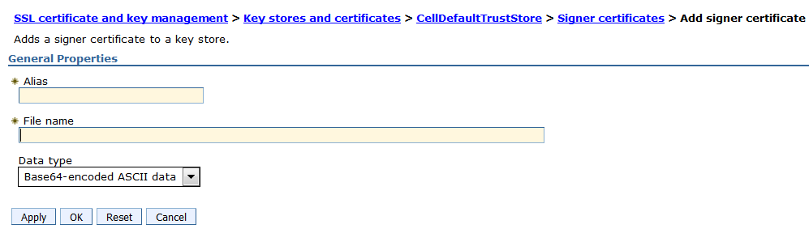

Enter Alias and File name (*.pem) which contains the content mentioned above, click OK to save.

click on Security ——> Global security, select Enable administrative security and click on apply at the end.



If application console cannot be used and then recycle all the servers.